THE HEART
Deoxygenated blood
Oxygenated blood

The P____________ A__________
Takes blood to the ___________

The A______ takes blood to the ________
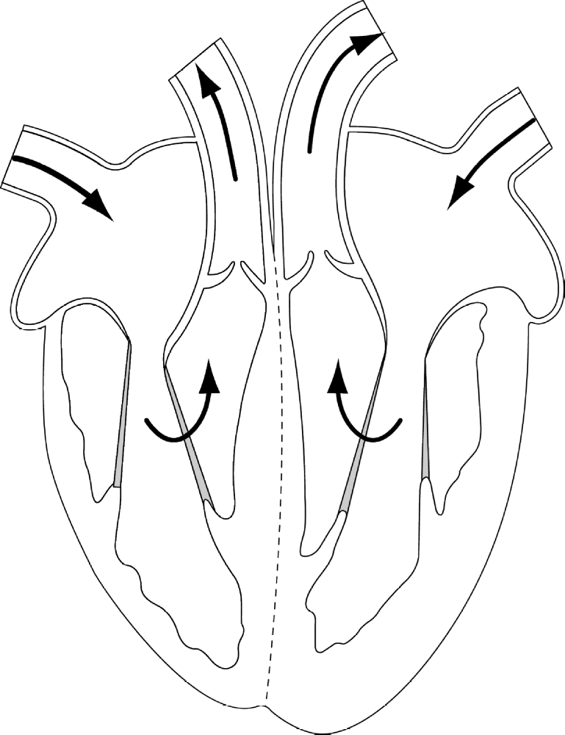
P________

V_______

V_______

C_______

L_______

A_______
R_______

A_______

R_______

V_______
L_______

V_______

The heart is made out of ____________ Muscle.
It is a double _________ that squeezes the blood around the ________ and to the ________. The _________ side pumps blood to the lungs to pick up ______________. The _________ side pumps blood around the rest of the body.
RIGHT, LEFT, CARDIAC, BODY, PUMP, LUNGS, OXYGEN

